**Elastic Block Storage:**

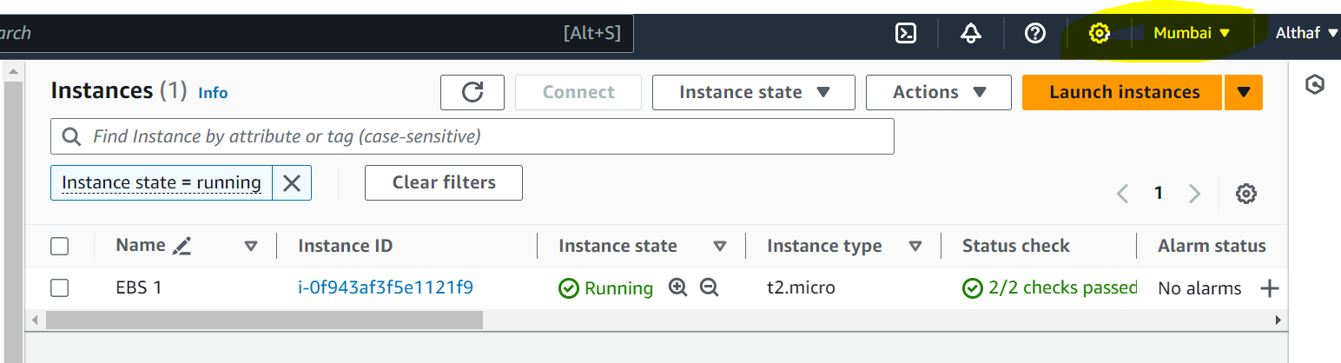

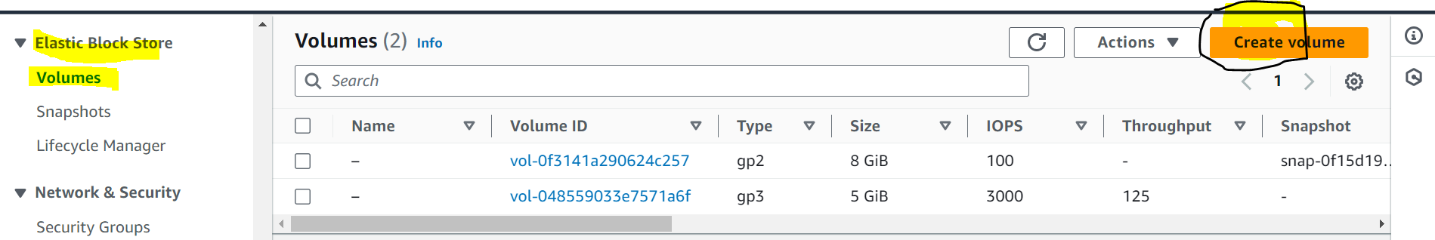

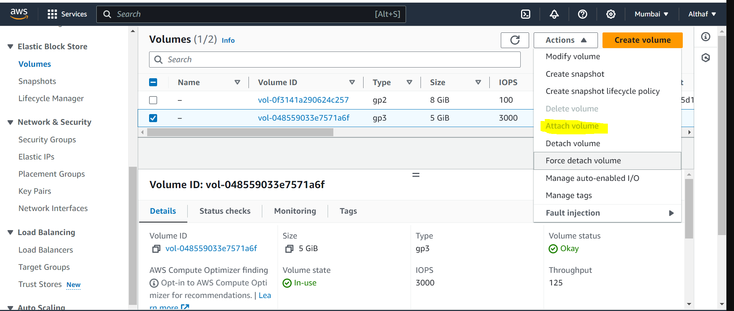

Volume has been attached to ec2 m/c to mount the volume we need to get into instance and do the below steps:

ubuntu@ip-172-31-47-196:~$ sudo apt update

sudo apt install apache2 wget unzip -y

wget https://www.tooplate.com/zip-templates/2128_tween_agency.zip

unzip 2128_tween_agency.zip

sudo cp -r 2128_tween_agency/* /var/www/html/

sudo systemctl restart apache2

Hit:1 http://ap-south-1.ec2.archive.ubuntu.com/ubuntu jammy InRelease

Get:2 http://ap-south-1.ec2.archive.ubuntu.com/ubuntu jammy-updates InRelease [119 kB]

Get:3 http://ap-south-1.ec2.archive.ubuntu.com/ubuntu jammy-backports InRelease [109 kB]

Get:4 http://ap-south-1.ec2.archive.ubuntu.com/ubuntu jammy/universe amd64 Packages [14.1 MB]

Get:5 http://security.ubuntu.com/ubuntu jammy-security InRelease [110 kB]

Get:6 http://ap-south-1.ec2.archive.ubuntu.com/ubuntu jammy/universe Translation-en [5652 kB]

Get:7 http://ap-south-1.ec2.archive.ubuntu.com/ubuntu jammy/universe amd64 c-n-f Metadata [286 kB]

Get:8 http://ap-south-1.ec2.archive.ubuntu.com/ubuntu jammy/multiverse amd64 Packages [217 kB]

Get:9 http://ap-south-1.ec2.archive.ubuntu.com/ubuntu jammy/multiverse Translation-en [112 kB]

Get:10 http://ap-south-1.ec2.archive.ubuntu.com/ubuntu jammy/multiverse amd64 c-n-f Metadata [8372 B]

Get:11 http://ap-south-1.ec2.archive.ubuntu.com/ubuntu jammy-updates/main amd64 Packages [1263 kB]

Get:12 http://ap-south-1.ec2.archive.ubuntu.com/ubuntu jammy-updates/main Translation-en [260 kB]

Get:13 http://ap-south-1.ec2.archive.ubuntu.com/ubuntu jammy-updates/restricted amd64 Packages [1250 kB]

Get:14 http://ap-south-1.ec2.archive.ubuntu.com/ubuntu jammy-updates/restricted Translation-en [203 kB]

Get:15 http://ap-south-1.ec2.archive.ubuntu.com/ubuntu jammy-updates/universe amd64 Packages [1020 kB]

Get:16 http://ap-south-1.ec2.archive.ubuntu.com/ubuntu jammy-updates/universe Translation-en [226 kB]

Get:17 http://ap-south-1.ec2.archive.ubuntu.com/ubuntu jammy-updates/universe amd64 c-n-f Metadata [22.1 kB]

Get:18 http://ap-south-1.ec2.archive.ubuntu.com/ubuntu jammy-updates/multiverse amd64 Packages [41.6 kB]

Get:19 http://ap-south-1.ec2.archive.ubuntu.com/ubuntu jammy-updates/multiverse Translation-en [9768 B]

Get:20 http://ap-south-1.ec2.archive.ubuntu.com/ubuntu jammy-updates/multiverse amd64 c-n-f Metadata [472 B]

Get:21 http://ap-south-1.ec2.archive.ubuntu.com/ubuntu jammy-backports/main amd64 Packages [41.7 kB]

Get:22 http://ap-south-1.ec2.archive.ubuntu.com/ubuntu jammy-backports/main Translation-en [10.5 kB]

Get:23 http://ap-south-1.ec2.archive.ubuntu.com/ubuntu jammy-backports/main amd64 c-n-f Metadata [388 B]

Get:24 http://ap-south-1.ec2.archive.ubuntu.com/ubuntu jammy-backports/restricted amd64 c-n-f Metadata [116 B]

Get:25 http://ap-south-1.ec2.archive.ubuntu.com/ubuntu jammy-backports/universe amd64 Packages [24.3 kB]

Get:26 http://ap-south-1.ec2.archive.ubuntu.com/ubuntu jammy-backports/universe Translation-en [16.5 kB]

Get:27 http://ap-south-1.ec2.archive.ubuntu.com/ubuntu jammy-backports/universe amd64 c-n-f Metadata [644 B]

Get:28 http://ap-south-1.ec2.archive.ubuntu.com/ubuntu jammy-backports/multiverse amd64 c-n-f Metadata [116 B]

Get:29 http://security.ubuntu.com/ubuntu jammy-security/main amd64 Packages [1051 kB]

Get:30 http://security.ubuntu.com/ubuntu jammy-security/main Translation-en [200 kB]

Get:31 http://security.ubuntu.com/ubuntu jammy-security/restricted amd64 Packages [1226 kB]

Get:32 http://security.ubuntu.com/ubuntu jammy-security/restricted Translation-en [200 kB]

Get:33 http://security.ubuntu.com/ubuntu jammy-security/universe amd64 Packages [823 kB]

Get:34 http://security.ubuntu.com/ubuntu jammy-security/universe Translation-en [156 kB]

Get:35 http://security.ubuntu.com/ubuntu jammy-security/universe amd64 c-n-f Metadata [16.8 kB]

Get:36 http://security.ubuntu.com/ubuntu jammy-security/multiverse amd64 Packages [36.5 kB]

Get:37 http://security.ubuntu.com/ubuntu jammy-security/multiverse Translation-en [7060 B]

Get:38 http://security.ubuntu.com/ubuntu jammy-security/multiverse amd64 c-n-f Metadata [260 B]

Fetched 28.8 MB in 6s (5153 kB/s)

Reading package lists... Done

Building dependency tree... Done

Reading state information... Done

26 packages can be upgraded. Run 'apt list --upgradable' to see them.

Reading package lists... Done

Building dependency tree... Done

Reading state information... Done

wget is already the newest version (1.21.2-2ubuntu1).

wget set to manually installed.

The following additional packages will be installed:

apache2-bin apache2-data apache2-utils bzip2 libapr1 libaprutil1 libaprutil1-dbd-sqlite3 libaprutil1-ldap liblua5.3-0 mailcap

mime-support ssl-cert

Suggested packages:

apache2-doc apache2-suexec-pristine | apache2-suexec-custom www-browser bzip2-doc zip

The following NEW packages will be installed:

apache2 apache2-bin apache2-data apache2-utils bzip2 libapr1 libaprutil1 libaprutil1-dbd-sqlite3 libaprutil1-ldap liblua5.3-0 mailcap

mime-support ssl-cert unzip

0 upgraded, 14 newly installed, 0 to remove and 26 not upgraded.

Need to get 2313 kB of archives.

After this operation, 8903 kB of additional disk space will be used.

Get:1 http://ap-south-1.ec2.archive.ubuntu.com/ubuntu jammy-updates/main amd64 libapr1 amd64 1.7.0-8ubuntu0.22.04.1 [108 kB]

Get:2 http://ap-south-1.ec2.archive.ubuntu.com/ubuntu jammy-updates/main amd64 libaprutil1 amd64 1.6.1-5ubuntu4.22.04.2 [92.8 kB]

Get:3 http://ap-south-1.ec2.archive.ubuntu.com/ubuntu jammy-updates/main amd64 libaprutil1-dbd-sqlite3 amd64 1.6.1-5ubuntu4.22.04.2 [11.3 kB]

Get:4 http://ap-south-1.ec2.archive.ubuntu.com/ubuntu jammy-updates/main amd64 libaprutil1-ldap amd64 1.6.1-5ubuntu4.22.04.2 [9170 B]

Get:5 http://ap-south-1.ec2.archive.ubuntu.com/ubuntu jammy/main amd64 liblua5.3-0 amd64 5.3.6-1build1 [140 kB]

Get:6 http://ap-south-1.ec2.archive.ubuntu.com/ubuntu jammy-updates/main amd64 apache2-bin amd64 2.4.52-1ubuntu4.7 [1346 kB]

Get:7 http://ap-south-1.ec2.archive.ubuntu.com/ubuntu jammy-updates/main amd64 apache2-data all 2.4.52-1ubuntu4.7 [165 kB]

Get:8 http://ap-south-1.ec2.archive.ubuntu.com/ubuntu jammy-updates/main amd64 apache2-utils amd64 2.4.52-1ubuntu4.7 [88.8 kB]

Get:9 http://ap-south-1.ec2.archive.ubuntu.com/ubuntu jammy/main amd64 mailcap all 3.70+nmu1ubuntu1 [23.8 kB]

Get:10 http://ap-south-1.ec2.archive.ubuntu.com/ubuntu jammy/main amd64 mime-support all 3.66 [3696 B]

Get:11 http://ap-south-1.ec2.archive.ubuntu.com/ubuntu jammy-updates/main amd64 apache2 amd64 2.4.52-1ubuntu4.7 [97.8 kB]

Get:12 http://ap-south-1.ec2.archive.ubuntu.com/ubuntu jammy/main amd64 bzip2 amd64 1.0.8-5build1 [34.8 kB]

Get:13 http://ap-south-1.ec2.archive.ubuntu.com/ubuntu jammy/main amd64 ssl-cert all 1.1.2 [17.4 kB]

Get:14 http://ap-south-1.ec2.archive.ubuntu.com/ubuntu jammy-updates/main amd64 unzip amd64 6.0-26ubuntu3.1 [174 kB]

Fetched 2313 kB in 0s (37.0 MB/s)

Preconfiguring packages ...

Selecting previously unselected package libapr1:amd64.

(Reading database ... 64799 files and directories currently installed.)

Preparing to unpack .../00-libapr1_1.7.0-8ubuntu0.22.04.1_amd64.deb ...

Unpacking libapr1:amd64 (1.7.0-8ubuntu0.22.04.1) ...

Selecting previously unselected package libaprutil1:amd64.

Preparing to unpack .../01-libaprutil1_1.6.1-5ubuntu4.22.04.2_amd64.deb ...

Unpacking libaprutil1:amd64 (1.6.1-5ubuntu4.22.04.2) ...

Selecting previously unselected package libaprutil1-dbd-sqlite3:amd64.

Preparing to unpack .../02-libaprutil1-dbd-sqlite3_1.6.1-5ubuntu4.22.04.2_amd64.deb ...

Unpacking libaprutil1-dbd-sqlite3:amd64 (1.6.1-5ubuntu4.22.04.2) ...

Selecting previously unselected package libaprutil1-ldap:amd64.

Preparing to unpack .../03-libaprutil1-ldap_1.6.1-5ubuntu4.22.04.2_amd64.deb ...

Unpacking libaprutil1-ldap:amd64 (1.6.1-5ubuntu4.22.04.2) ...

Selecting previously unselected package liblua5.3-0:amd64.

Preparing to unpack .../04-liblua5.3-0_5.3.6-1build1_amd64.deb ...

Unpacking liblua5.3-0:amd64 (5.3.6-1build1) ...

Selecting previously unselected package apache2-bin.

Preparing to unpack .../05-apache2-bin_2.4.52-1ubuntu4.7_amd64.deb ...

Unpacking apache2-bin (2.4.52-1ubuntu4.7) ...

Selecting previously unselected package apache2-data.

Preparing to unpack .../06-apache2-data_2.4.52-1ubuntu4.7_all.deb ...

Unpacking apache2-data (2.4.52-1ubuntu4.7) ...

Selecting previously unselected package apache2-utils.

Preparing to unpack .../07-apache2-utils_2.4.52-1ubuntu4.7_amd64.deb ...

Unpacking apache2-utils (2.4.52-1ubuntu4.7) ...

Selecting previously unselected package mailcap.

Preparing to unpack .../08-mailcap_3.70+nmu1ubuntu1_all.deb ...

Unpacking mailcap (3.70+nmu1ubuntu1) ...

Selecting previously unselected package mime-support.

Preparing to unpack .../09-mime-support_3.66_all.deb ...

Unpacking mime-support (3.66) ...

Selecting previously unselected package apache2.

Preparing to unpack .../10-apache2_2.4.52-1ubuntu4.7_amd64.deb ...

Unpacking apache2 (2.4.52-1ubuntu4.7) ...

Selecting previously unselected package bzip2.

Preparing to unpack .../11-bzip2_1.0.8-5build1_amd64.deb ...

Unpacking bzip2 (1.0.8-5build1) ...

Selecting previously unselected package ssl-cert.

Preparing to unpack .../12-ssl-cert_1.1.2_all.deb ...

Unpacking ssl-cert (1.1.2) ...

Selecting previously unselected package unzip.

Preparing to unpack .../13-unzip_6.0-26ubuntu3.1_amd64.deb ...

Unpacking unzip (6.0-26ubuntu3.1) ...

Setting up unzip (6.0-26ubuntu3.1) ...

Setting up libapr1:amd64 (1.7.0-8ubuntu0.22.04.1) ...

Setting up bzip2 (1.0.8-5build1) ...

Setting up ssl-cert (1.1.2) ...

Setting up liblua5.3-0:amd64 (5.3.6-1build1) ...

Setting up apache2-data (2.4.52-1ubuntu4.7) ...

Setting up mailcap (3.70+nmu1ubuntu1) ...

Setting up libaprutil1:amd64 (1.6.1-5ubuntu4.22.04.2) ...

Setting up mime-support (3.66) ...

Setting up libaprutil1-ldap:amd64 (1.6.1-5ubuntu4.22.04.2) ...

Setting up libaprutil1-dbd-sqlite3:amd64 (1.6.1-5ubuntu4.22.04.2) ...

Setting up apache2-utils (2.4.52-1ubuntu4.7) ...

Setting up apache2-bin (2.4.52-1ubuntu4.7) ...

Setting up apache2 (2.4.52-1ubuntu4.7) ...

Enabling module mpm_event.

Enabling module authz_core.

Enabling module authz_host.

Enabling module authn_core.

Enabling module auth_basic.

Enabling module access_compat.

Enabling module authn_file.

Enabling module authz_user.

Enabling module alias.

Enabling module dir.

Enabling module autoindex.

Enabling module env.

Enabling module mime.

Enabling module negotiation.

Enabling module setenvif.

Enabling module filter.

Enabling module deflate.

Enabling module status.

Enabling module reqtimeout.

Enabling conf charset.

Enabling conf localized-error-pages.

Enabling conf other-vhosts-access-log.

Enabling conf security.

Enabling conf serve-cgi-bin.

Enabling site 000-default.

Created symlink /etc/systemd/system/multi-user.target.wants/apache2.service → /lib/systemd/system/apache2.service.

Created symlink /etc/systemd/system/multi-user.target.wants/apache-htcacheclean.service → /lib/systemd/system/apache-htcacheclean.service.

Processing triggers for ufw (0.36.1-4ubuntu0.1) ...

Processing triggers for man-db (2.10.2-1) ...

Processing triggers for libc-bin (2.35-0ubuntu3.4) ...

Scanning processes...

Scanning linux images...

Running kernel seems to be up-to-date.

No services need to be restarted.

No containers need to be restarted.

No user sessions are running outdated binaries.

No VM guests are running outdated hypervisor (qemu) binaries on this host.

--2023-12-22 14:28:06-- https://www.tooplate.com/zip-templates/2128_tween_agency.zip

Resolving www.tooplate.com (www.tooplate.com)... 72.52.176.250

Connecting to www.tooplate.com (www.tooplate.com)|72.52.176.250|:443... connected.

HTTP request sent, awaiting response... 200 OK

Length: 2904556 (2.8M) [application/zip]

Saving to: ‘2128_tween_agency.zip’

2128_tween_agency.zip 100%[===============================================================>] 2.77M 1.42MB/s in 2.0s

2023-12-22 14:28:09 (1.42 MB/s) - ‘2128_tween_agency.zip’ saved [2904556/2904556]

Archive: 2128_tween_agency.zip

creating: 2128_tween_agency/

creating: 2128_tween_agency/css/

inflating: 2128_tween_agency/css/bootstrap-icons.css

inflating: 2128_tween_agency/css/bootstrap.min.css

inflating: 2128_tween_agency/css/magnific-popup.css

inflating: 2128_tween_agency/css/tooplate-tween-agency.css

creating: 2128_tween_agency/fonts/

inflating: 2128_tween_agency/fonts/bootstrap-icons.woff

inflating: 2128_tween_agency/fonts/bootstrap-icons.woff2

creating: 2128_tween_agency/images/

inflating: 2128_tween_agency/images/dream-about-working-corporation-became-true.jpg

inflating: 2128_tween_agency/images/maria-stewart-p4tj0g-_aMM-unsplash.jpg

inflating: 2128_tween_agency/images/php-programming-html-coding-cyberspace-concept.jpg

creating: 2128_tween_agency/images/services/

inflating: 2128_tween_agency/images/services/undraw_content_team_3epn.svg

inflating: 2128_tween_agency/images/services/undraw_Online_page_re_lhgx.svg

inflating: 2128_tween_agency/images/services/undraw_online_transactions_02ka.svg

creating: 2128_tween_agency/images/slide/

inflating: 2128_tween_agency/images/slide/microsoft-edge-FAaz8lkinzs-unsplash.jpg

inflating: 2128_tween_agency/images/slide/surface-1x5jnhtlp3Y-unsplash.jpg

inflating: 2128_tween_agency/images/slide/surface-71_s6RDJpGc-unsplash.jpg

inflating: 2128_tween_agency/images/webpage-browser-digital-icon-symbols-concept.jpg

creating: 2128_tween_agency/images/work/

inflating: 2128_tween_agency/images/work/anthony-espinosa-pYQSM-p_0_c-unsplash.jpg

inflating: 2128_tween_agency/images/work/business-chart-visual-graphics-report-concept.jpg

inflating: 2128_tween_agency/images/work/mos-sukjaroenkraisri-jz8AmJDyhig-unsplash.jpg

inflating: 2128_tween_agency/images/work/samantha-gades-lf2pD--wIUA-unsplash.jpg

inflating: 2128_tween_agency/images/work/tyler-nix-HmVQh_EQJhY-unsplash.jpg

inflating: 2128_tween_agency/index.html

creating: 2128_tween_agency/js/

inflating: 2128_tween_agency/js/bootstrap.min.js

inflating: 2128_tween_agency/js/click-scroll.js

inflating: 2128_tween_agency/js/custom.js

inflating: 2128_tween_agency/js/jquery.backstretch.min.js

inflating: 2128_tween_agency/js/jquery.magnific-popup.min.js

inflating: 2128_tween_agency/js/jquery.min.js

inflating: 2128_tween_agency/js/magnific-popup-options.js

inflating: 2128_tween_agency/js/popper.js

inflating: 2128_tween_agency/ABOUT THIS TEMPLATE.txt

ubuntu@ip-172-31-47-196:~$ sudo -i

root@ip-172-31-47-196:~# df -h

Filesystem Size Used Avail Use% Mounted on

/dev/root 7.6G 1.8G 5.8G 24% /

tmpfs 475M 0 475M 0% /dev/shm

tmpfs 190M 860K 190M 1% /run

tmpfs 5.0M 0 5.0M 0% /run/lock

/dev/xvda15 105M 6.1M 99M 6% /boot/efi

tmpfs 95M 4.0K 95M 1% /run/user/1000

root@ip-172-31-47-196:~# fdisk -l

Disk /dev/loop0: 24.9 MiB, 26112000 bytes, 51000 sectors

Units: sectors of 1 * 512 = 512 bytes

Sector size (logical/physical): 512 bytes / 512 bytes

I/O size (minimum/optimal): 512 bytes / 512 bytes

Disk /dev/loop1: 55.66 MiB, 58363904 bytes, 113992 sectors

Units: sectors of 1 * 512 = 512 bytes

Sector size (logical/physical): 512 bytes / 512 bytes

I/O size (minimum/optimal): 512 bytes / 512 bytes

Disk /dev/loop2: 63.46 MiB, 66547712 bytes, 129976 sectors

Units: sectors of 1 * 512 = 512 bytes

Sector size (logical/physical): 512 bytes / 512 bytes

I/O size (minimum/optimal): 512 bytes / 512 bytes

Disk /dev/loop3: 111.95 MiB, 117387264 bytes, 229272 sectors

Units: sectors of 1 * 512 = 512 bytes

Sector size (logical/physical): 512 bytes / 512 bytes

I/O size (minimum/optimal): 512 bytes / 512 bytes

Disk /dev/loop4: 40.86 MiB, 42840064 bytes, 83672 sectors

Units: sectors of 1 * 512 = 512 bytes

Sector size (logical/physical): 512 bytes / 512 bytes

I/O size (minimum/optimal): 512 bytes / 512 bytes

Disk /dev/xvda: 8 GiB, 8589934592 bytes, 16777216 sectors

Units: sectors of 1 * 512 = 512 bytes

Sector size (logical/physical): 512 bytes / 512 bytes

I/O size (minimum/optimal): 512 bytes / 512 bytes

Disklabel type: gpt

Disk identifier: 8F814D15-0F5D-40E2-8A1E-E14BBDFCE594

Device Start End Sectors Size Type

/dev/xvda1 227328 16777182 16549855 7.9G Linux filesystem

/dev/xvda14 2048 10239 8192 4M BIOS boot

/dev/xvda15 10240 227327 217088 106M EFI System

Partition table entries are not in disk order.

Disk /dev/xvdf: 5 GiB, 5368709120 bytes, 10485760 sectors

Units: sectors of 1 * 512 = 512 bytes

Sector size (logical/physical): 512 bytes / 512 bytes

I/O size (minimum/optimal): 512 bytes / 512 bytes

root@ip-172-31-47-196:~# fdisk /dev/xvdf

Welcome to fdisk (util-linux 2.37.2).

Changes will remain in memory only, until you decide to write them.

Be careful before using the write command.

Device does not contain a recognized partition table.

Created a new DOS disklabel with disk identifier 0x329b3bb5.

Command (m for help): n

Partition type

p primary (0 primary, 0 extended, 4 free)

e extended (container for logical partitions)

Select (default p): p

Partition number (1-4, default 1):

First sector (2048-10485759, default 2048):

Last sector, +/-sectors or +/-size{K,M,G,T,P} (2048-10485759, default 10485759):

Created a new partition 1 of type 'Linux' and of size 5 GiB.

Command (m for help): w

The partition table has been altered.

Calling ioctl() to re-read partition table.

Syncing disks.

root@ip-172-31-47-196:~# fdisk -l

Disk /dev/loop0: 24.9 MiB, 26112000 bytes, 51000 sectors

Units: sectors of 1 * 512 = 512 bytes

Sector size (logical/physical): 512 bytes / 512 bytes

I/O size (minimum/optimal): 512 bytes / 512 bytes

Disk /dev/loop1: 55.66 MiB, 58363904 bytes, 113992 sectors

Units: sectors of 1 * 512 = 512 bytes

Sector size (logical/physical): 512 bytes / 512 bytes

I/O size (minimum/optimal): 512 bytes / 512 bytes

Disk /dev/loop2: 63.46 MiB, 66547712 bytes, 129976 sectors

Units: sectors of 1 * 512 = 512 bytes

Sector size (logical/physical): 512 bytes / 512 bytes

I/O size (minimum/optimal): 512 bytes / 512 bytes

Disk /dev/loop3: 111.95 MiB, 117387264 bytes, 229272 sectors

Units: sectors of 1 * 512 = 512 bytes

Sector size (logical/physical): 512 bytes / 512 bytes

I/O size (minimum/optimal): 512 bytes / 512 bytes

Disk /dev/loop4: 40.86 MiB, 42840064 bytes, 83672 sectors

Units: sectors of 1 * 512 = 512 bytes

Sector size (logical/physical): 512 bytes / 512 bytes

I/O size (minimum/optimal): 512 bytes / 512 bytes

Disk /dev/xvda: 8 GiB, 8589934592 bytes, 16777216 sectors

Units: sectors of 1 * 512 = 512 bytes

Sector size (logical/physical): 512 bytes / 512 bytes

I/O size (minimum/optimal): 512 bytes / 512 bytes

Disklabel type: gpt

Disk identifier: 8F814D15-0F5D-40E2-8A1E-E14BBDFCE594

Device Start End Sectors Size Type

/dev/xvda1 227328 16777182 16549855 7.9G Linux filesystem

/dev/xvda14 2048 10239 8192 4M BIOS boot

/dev/xvda15 10240 227327 217088 106M EFI System

Partition table entries are not in disk order.

Disk /dev/xvdf: 5 GiB, 5368709120 bytes, 10485760 sectors

Units: sectors of 1 * 512 = 512 bytes

Sector size (logical/physical): 512 bytes / 512 bytes

I/O size (minimum/optimal): 512 bytes / 512 bytes

Disklabel type: dos

Disk identifier: 0x329b3bb5

Device Boot Start End Sectors Size Id Type

/dev/xvdf1 2048 10485759 10483712 5G 83 Linux

root@ip-172-31-47-196:~# lsblk

NAME MAJ:MIN RM SIZE RO TYPE MOUNTPOINTS

loop0 7:0 0 24.9M 1 loop /snap/amazon-ssm-agent/7628

loop1 7:1 0 55.7M 1 loop /snap/core18/2812

loop2 7:2 0 63.5M 1 loop /snap/core20/2015

loop3 7:3 0 111.9M 1 loop /snap/lxd/24322

loop4 7:4 0 40.9M 1 loop /snap/snapd/20290

xvda 202:0 0 8G 0 disk

├─xvda1 202:1 0 7.9G 0 part /

├─xvda14 202:14 0 4M 0 part

└─xvda15 202:15 0 106M 0 part /boot/efi

xvdf 202:80 0 5G 0 disk

└─xvdf1 202:81 0 5G 0 part

root@ip-172-31-47-196:~# mkfs -t ext4 /dev/xvdf1

mke2fs 1.46.5 (30-Dec-2021)

Creating filesystem with 1310464 4k blocks and 327680 inodes

Filesystem UUID: 81396f65-af9a-48fa-b85c-ba03fb6221b6

Superblock backups stored on blocks:

32768, 98304, 163840, 229376, 294912, 819200, 884736

Allocating group tables: done

Writing inode tables: done

Creating journal (16384 blocks): done

Writing superblocks and filesystem accounting information: done

root@ip-172-31-47-196:~# mount /dev/xvdf1 /var/www/html/images

root@ip-172-31-47-196:~# lsblk

NAME MAJ:MIN RM SIZE RO TYPE MOUNTPOINTS

loop0 7:0 0 24.9M 1 loop /snap/amazon-ssm-agent/7628

loop1 7:1 0 55.7M 1 loop /snap/core18/2812

loop2 7:2 0 63.5M 1 loop /snap/core20/2015

loop3 7:3 0 111.9M 1 loop /snap/lxd/24322

loop4 7:4 0 40.9M 1 loop /snap/snapd/20290

xvda 202:0 0 8G 0 disk

├─xvda1 202:1 0 7.9G 0 part /

├─xvda14 202:14 0 4M 0 part

└─xvda15 202:15 0 106M 0 part /boot/efi

xvdf 202:80 0 5G 0 disk

└─xvdf1 202:81 0 5G 0 part /var/www/html/images

root@ip-172-31-47-196:~# vi nano /etc/fstab

2 files to edit

root@ip-172-31-47-196:~# mount -a

root@ip-172-31-47-196:~# df -h

Filesystem Size Used Avail Use% Mounted on

/dev/root 7.6G 1.8G 5.8G 24% /

tmpfs 475M 0 475M 0% /dev/shm

tmpfs 190M 864K 190M 1% /run

tmpfs 5.0M 0 5.0M 0% /run/lock

/dev/xvda15 105M 6.1M 99M 6% /boot/efi

tmpfs 95M 4.0K 95M 1% /run/user/1000

/dev/xvdf1 4.9G 24K 4.6G 1% /var/www/html/images

root@ip-172-31-47-196:~#

—-------------------------------------------------------------------------------------

—---------------------------------------------------------------------------------------------------

—----------------------------------------------------------------------------------------------------------------

—-------------------------------------------------------------------------------------------------------------------------

—-----------------------------------------------------------------------------

**Snapshot:**

Launched a ec2 m/c in different AZ taking snap of previous created volume, to attach the volume in the presently created EC2

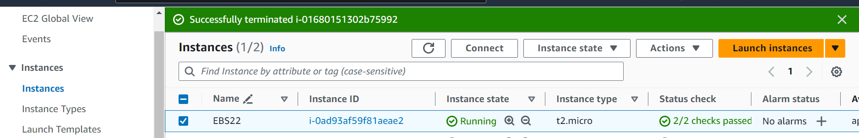

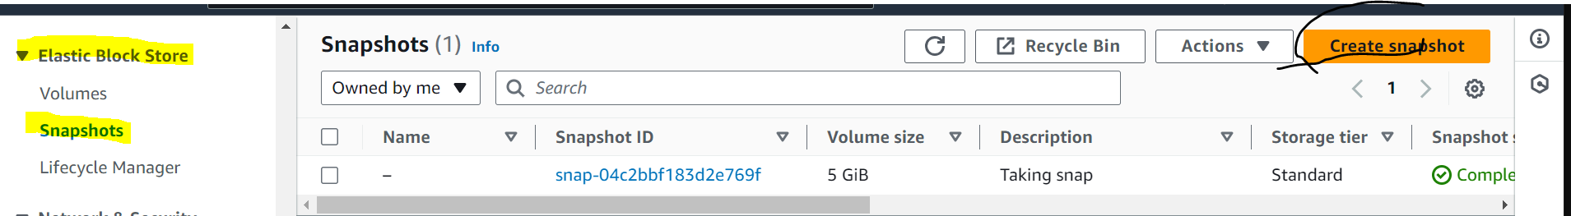

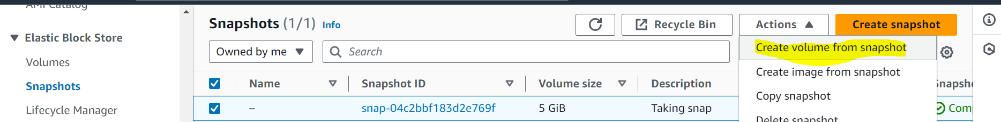

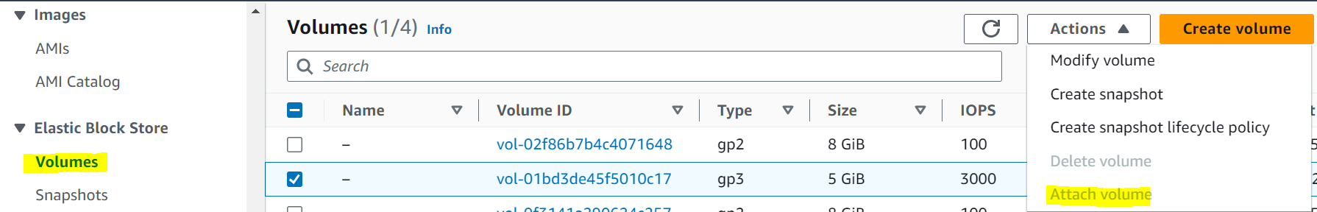

Created an volume using snapshot now enter into the Ec2 to mount

ubuntu@ip-172-31-10-152:~$ sudo su

root@ip-172-31-10-152:/home/ubuntu# fdisk -l

Disk /dev/loop0: 24.9 MiB, 26112000 bytes, 51000 sectors

Units: sectors of 1 * 512 = 512 bytes

Sector size (logical/physical): 512 bytes / 512 bytes

I/O size (minimum/optimal): 512 bytes / 512 bytes

Disk /dev/loop1: 55.66 MiB, 58363904 bytes, 113992 sectors

Units: sectors of 1 * 512 = 512 bytes

Sector size (logical/physical): 512 bytes / 512 bytes

I/O size (minimum/optimal): 512 bytes / 512 bytes

Disk /dev/loop2: 63.46 MiB, 66547712 bytes, 129976 sectors

Units: sectors of 1 * 512 = 512 bytes

Sector size (logical/physical): 512 bytes / 512 bytes

I/O size (minimum/optimal): 512 bytes / 512 bytes

Disk /dev/loop3: 111.95 MiB, 117387264 bytes, 229272 sectors

Units: sectors of 1 * 512 = 512 bytes

Sector size (logical/physical): 512 bytes / 512 bytes

I/O size (minimum/optimal): 512 bytes / 512 bytes

Disk /dev/loop4: 40.86 MiB, 42840064 bytes, 83672 sectors

Units: sectors of 1 * 512 = 512 bytes

Sector size (logical/physical): 512 bytes / 512 bytes

I/O size (minimum/optimal): 512 bytes / 512 bytes

Disk /dev/xvda: 8 GiB, 8589934592 bytes, 16777216 sectors

Units: sectors of 1 * 512 = 512 bytes

Sector size (logical/physical): 512 bytes / 512 bytes

I/O size (minimum/optimal): 512 bytes / 512 bytes

Disklabel type: gpt

Disk identifier: 8F814D15-0F5D-40E2-8A1E-E14BBDFCE594

Device Start End Sectors Size Type

/dev/xvda1 227328 16777182 16549855 7.9G Linux filesystem

/dev/xvda14 2048 10239 8192 4M BIOS boot

/dev/xvda15 10240 227327 217088 106M EFI System

Partition table entries are not in disk order.

Disk /dev/xvdf: 5 GiB, 5368709120 bytes, 10485760 sectors

Units: sectors of 1 * 512 = 512 bytes

Sector size (logical/physical): 512 bytes / 512 bytes

I/O size (minimum/optimal): 512 bytes / 512 bytes

Disklabel type: dos

Disk identifier: 0x329b3bb5

Device Boot Start End Sectors Size Id Type

/dev/xvdf1 2048 10485759 10483712 5G 83 Linux

root@ip-172-31-10-152:/home/ubuntu# df -h

Filesystem Size Used Avail Use% Mounted on

/dev/root 7.6G 1.6G 6.0G 21% /

tmpfs 475M 0 475M 0% /dev/shm

tmpfs 190M 848K 190M 1% /run

tmpfs 5.0M 0 5.0M 0% /run/lock

/dev/xvda15 105M 6.1M 99M 6% /boot/efi

tmpfs 95M 4.0K 95M 1% /run/user/1000

root@ip-172-31-10-152:/home/ubuntu# mkdir /mnt/myvol

root@ip-172-31-10-152:/home/ubuntu# mkfs -t ext4 /dev/xvdf1

mke2fs 1.46.5 (30-Dec-2021)

/dev/xvdf1 contains a ext4 file system

last mounted on Fri Dec 22 14:33:30 2023

Proceed anyway? (y,N) y

Creating filesystem with 1310464 4k blocks and 327680 inodes

Filesystem UUID: fa98f22a-4283-4982-a66d-94ced9f290c7

Superblock backups stored on blocks:

32768, 98304, 163840, 229376, 294912, 819200, 884736

Allocating group tables: done

Writing inode tables: done

Creating journal (16384 blocks): done

Writing superblocks and filesystem accounting information: done

root@ip-172-31-10-152:/home/ubuntu# mkfs -t ext4 /dev/xvdf

mke2fs 1.46.5 (30-Dec-2021)

Found a dos partition table in /dev/xvdf

Proceed anyway? (y,N) y

Creating filesystem with 1310720 4k blocks and 327680 inodes

Filesystem UUID: d21e0dcf-d8c1-4cb7-9a4d-8c4f28fcd291

Superblock backups stored on blocks:

32768, 98304, 163840, 229376, 294912, 819200, 884736

Allocating group tables: done

Writing inode tables: done

Creating journal (16384 blocks): done

Writing superblocks and filesystem accounting information: done

root@ip-172-31-10-152:/home/ubuntu# mount /dev/xvdf /mnt/myvol

root@ip-172-31-10-152:/home/ubuntu# vi nano /etc/fstab

2 files to edit

root@ip-172-31-10-152:/home/ubuntu# mount -a

root@ip-172-31-10-152:/home/ubuntu# df -h

Filesystem Size Used Avail Use% Mounted on

/dev/root 7.6G 1.6G 6.0G 21% /

tmpfs 475M 0 475M 0% /dev/shm

tmpfs 190M 848K 190M 1% /run

tmpfs 5.0M 0 5.0M 0% /run/lock

/dev/xvda15 105M 6.1M 99M 6% /boot/efi

tmpfs 95M 4.0K 95M 1% /run/user/1000

/dev/xvdf 4.9G 24K 4.6G 1% /mnt/myvol

root@ip-172-31-10-152:/home/ubuntu#